*The following material is provided for informational purposes only. Before taking any action that could have legal or other significant consequences, consult with a qualified professional who can provide guidance tailored to your unique circumstances.*

**The Challenge of a Hybrid Workplace for Architects and Engineers**

*By Diane P. Mika Senior Vice President, Risk Management Officer Berkley Alliance Managers*

The COVID-19 Public Health Emergency may have officially ended, but its effects have forever changed people’s lives. While the concept of the hybrid work environment had already been gaining ground before 2020, COVID-19 gave many employees their first taste of working from home, providing much more flexibility to accomplish their work on their own terms. Many firms implemented a hybrid strategy in returning to the office, both as a social distancing tactic as well as a way to placate employees who very much liked working from home and wanted to continue to do so, at least part of the time.

Converting to a hybrid office approach means making not only operational changes but also physical changes. Flexible spaces where projects define the space, rather than people, have become the hallmark of a hybrid office. Since independent work can more easily be accomplished while working remotely, the hybrid office space prioritizes the variety of collaboration spaces for in-person meetings of various sizes. Spaces might include open common spaces, team huddle areas, quiet zones, booths, library areas, small informal spots, and large meeting spaces. Technology and digital tools, health and wellness, and equity all factor into a greater emphasis on fostering collaboration, culture, and inclusion in a hybrid office.

A full-blown remote work approach succeeds for some employees and in some industries, but not all. Some industries, like design and engineering, require a highly collaborative team working together to produce the best results. Others, like law practices and some government agencies, are steeped in tradition and just not as open to change. The hybrid workplace might be the sweet spot in maintaining a center of operations while accommodating today’s increasingly diverse workforce.

There are risks and challenges that leadership must recognize and address for the hybrid approach to be successful.

* Arguably the most critical risk is that of maintaining **network integrity** and **cybersecurity** while facilitating remote work. Controlling access to sensitive data, establishing a clear audit trail, and prioritizing employee awareness and training are critical to minimizing the possibility of a cyber-attack.
* The erosion of the **company culture** is a significant and real concern as well. Having an active and intentional requirement for presence in the office, at a minimum for important in-person meetings and events can help to nurture and sustain a company’s shared goals and values.
* **Productivity levels** initially increased during the work-from-home time of the pandemic as measured by enhanced direct time ratios and resultant reduced overhead factors. Now those reported gains are questionable, and companies are looking at measuring outcomes instead of hours as a better performance measurement.
* The past several years have seen a great emphasis on **Diversity, Equity, and Inclusion** (DEI) in the workplace, and the hybrid workplace could potentially diminish the positive impacts that had been occurring. Policies, employee assistance and development programs, and an open and transparent commitment to DEI goals are just a few of the things that will ensure inclusivity and greater staff retention.

A hybrid solution offers a way to satisfy today’s increasingly diverse workforce. These are just a few of the highlights in this all-encompassing topic that continues to impact companies. The resource section below provides a list of articles that offer more in-depth information as a starting point for your examination into this important topic.

*These hyperlinks are provided solely for your convenience and do not imply Berkley Design Professional's approval or endorsement of such sites or the content therein; nor do they imply any endorsement of Berkley DP by the organizations or sites.*

**Design Firms:**

* <https://www.gensler.com/blog/5-considerations-for-a-better-hybrid-work-experience>
* <https://www.workdesign.com/2023/02/navigating-the-complexity-of-the-hybrid-workplace-design-process/>
* <https://gbdmagazine.com/hybrid-office-design/>
* <https://time.com/charter/6168505/architects-work-space/>

**Vendors:**

* <https://www.steelcase.com/eu-en/research/articles/topics/culture-talent/leadership-by-design/>
* <https://www.hermanmiller.com/content/dam/hermanmiller/documents/future_of_work/drivers_of_change_for_the_future_of_work.pdf>
* <https://k2space.co.uk/knowledge/hybrid-office-design/>

**Professional Journals and Associations:**

* <https://hbr.org/2021/03/designing-the-hybrid-office>
* <https://hbr.org/2021/09/12-questions-about-hybrid-work-answered>
* <https://www.iofficecorp.com/blog/hybrid-office-examples>
* <https://www.tallyworkspace.com/articles/an-interview-with-commercial-interior-designer-heather-lehmann-how-to-design-a-hybrid-office>

**Hybrid Work Risks:**

* <https://riskonnect.com/integrated-risk-management/hybrid-working-risks/>
* <https://www.mckinsey.com/capabilities/people-and-organizational-performance/our-insights/the-organization-blog/the-future-of-work-managing-three-risks-of-the-hybrid-workplace>
* <https://www.mckinsey.com/capabilities/people-and-organizational-performance/our-insights/the-organization-blog/the-future-of-the-workplace-embracing-change-and-fostering-connectivity>
* <https://hbr.org/2022/02/5-challenges-of-hybrid-work-and-how-to-overcome-them>
* <https://rmi.com.sg/2021/10/15/5-major-risks-of-hybrid-work-model/>
* <https://web-assets.bcg.com/74/33/14077446434fa8685891ba0e2e69/bcg-decoding-global-ways-of-working-mar-2021.pdf>
* <https://siepr.stanford.edu/publications/policy-brief/hybrid-future-work>
* <https://www.knightfrank.co.uk/office-space/insights/culture-and-space/creating-company-culture-in-a-hybrid-working-model/>
* <https://blog.darwinbox.com/diversity-equity-inclusion-hybrid-work>

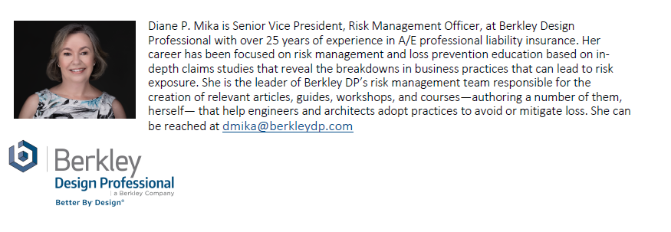

Information provided by Berkley Design Professional is for general interest and risk management purposes only and should not be construed as legal advice nor confirmation of insurance coverage. As laws regarding the use and enforceability of the information contained herein will vary depending upon jurisdiction, the user of the information should consult with an attorney experienced in the laws and regulations of the appropriate jurisdiction for the full legal implications of the information.

Practice management recommendations should be carefully reviewed and adapted for the particular project requirements, firm standards and protocols established by the design professional.

Products and services are provided by one or more insurance company subsidiaries of W. R. Berkley Corporation. Not all products and services are available in every jurisdiction, and the precise coverage afforded by any insurer is subject to the actual terms and conditions of the policies as issued.